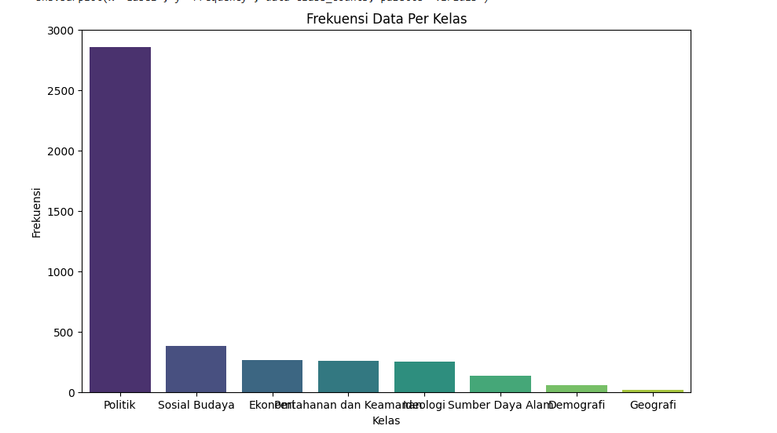

Label Frequency

0 Politik 2861

1 Sosial Budaya 384

2 Ekonomi 268

3 Pertahanan dan Keamanan 257

4 Ideologi 253

5 Sumber Daya Alam 134

6 Demografi 55

7 Geografi 19

Kata terbanyak digunakan per kelas

1. **SDA**

|  |  |
| --- | --- |
| kata | Frekuensi |
| Air | 23 |
| pertanian | 19 |
| Program | 18 |
| alam | 17 |
| Petani | 16 |
| Lingkungan | 14 |
| Nelayan | 12 |
| food | 12 |
| Indonesiasentris | 11 |
| Melanjutkan | 11 |
| Estate | 11 |
| Indonesiahijau | 10 |
| Anakamudaindonesiaemas | 10 |
| Desa | 9 |
| Bersih | 8 |
| Capres | 8 |
| Rumah | 8 |
| Lahan | 8 |
| Sumber | 8 |
| jawa | 7 |

1. **POLITIK**

|  |  |
| --- | --- |
| kata | Frekuensi |
| Capres | 355 |
| Rakyat | 323 |
| Jokowi | 253 |
| Debat | 207 |
| Politik | 198 |
| Pilpres | 196 |
| Coblos | 178 |
| Pemimpin | 174 |
| Program | 164 |
| Kampanye | 164 |
| Dukung | 156 |
| Perubahan | 154 |
| Negara | 141 |
| Pasangan | 141 |
| hebat | 139 |
| masyarakat | 137 |
| Dukungan | 133 |
| Pilih | 133 |
| Jakarta | 115 |
| Warga | 114 |

1. **DEMOGRAFI**

|  |  |
| --- | --- |
| kata | Frekuensi |
| Muda | 16 |
| Etnis | 12 |
| Kalangan | 12 |
| Generasi | 11 |
| Kalbar | 10 |
| Pendidikan | 9 |
| Anak | 9 |
| Tokoh | 8 |
| Keluarga | 8 |
| Masyarakat | 7 |
| Barat | 7 |
| Jawa | 7 |
| adat | 7 |
| Menengah | 6 |
| Mendukung | 6 |
| Program | 6 |
| Gratis | 6 |
| Prajurit | 6 |
| Desak | 6 |
| pendukung | 5 |

1. **PERTAHANAN KEAMANAN**

|  |  |
| --- | --- |
| kata | Frekuensi |
| Pertahanan | 111 |
| Tni | 44 |
| Keamanan | 37 |
| Coblos | 34 |
| Alutsista | 32 |
| Negara | 32 |
| Debat | 24 |
| Capres | 23 |
| Dulujokowisekarangganjar | 23 |
| Menteri | 21 |
| Menhan | 19 |
| Data | 18 |
| Boyolali | 18 |
| Relawan | 18 |
| Gaza | 15 |
| Oknum | 15 |
| Laut | 14 |
| Urut | 14 |
| Militer | 14 |
| salah | 14 |

1. **IDEOLOGI**

|  |  |
| --- | --- |
| kata | Frekuensi |
| Negara | 70 |
| Capres | 51 |
| Dasar | 48 |
| Aturan | 43 |
| Konstitusi | 40 |
| Pemimpin | 38 |
| Rakyat | 29 |
| Masyarakat | 28 |
| Hati | 27 |
| Calon | 26 |
| Bangsa | 26 |
| Program | 25 |
| Rekan | 24 |
| Ri | 23 |
| Urut | 23 |
| Tau | 23 |
| Nurani | 23 |
| Cawapres | 18 |
| Menjaga | 17 |
| Pilpres | 17 |

1. **EKONOMI**

|  |  |
| --- | --- |
| kata | Frekuensi |
| Ekonomi | 114 |
| Capres | 79 |
| Program | 77 |
| Petani | 57 |
| Cawapres | 52 |
| Pasangan | 44 |
| Nelayan | 42 |
| Kredit | 32 |
| Desa | 30 |
| Pertumbuhan | 26 |
| Pupuk | 23 |
| Umkm | 22 |
| Utang | 21 |
| Pertanian | 19 |
| Mendukung | 19 |
| Tumbuh | 19 |
| Gratis | 18 |
| Macet | 18 |
| Kesejahteraan | 17 |
| solusi | 17 |

1. **SOSIAL BUDAYA**

|  |  |
| --- | --- |
| kata | Frekuensi |
| Anak | 58 |
| Desak | 47 |
| Pendidikan | 45 |
| Program | 44 |
| Jawa | 36 |
| Warga | 33 |
| Masyarakat | 31 |
| Petani | 30 |
| Jakarta | 29 |
| Guru | 29 |
| Disabilitas | 28 |
| Muda | 26 |
| Rakyat | 25 |
| Papua | 25 |
| Acara | 24 |
| Capres | 23 |
| Barat | 22 |
| Salah | 22 |
| Perempuan | 21 |
| Sekolah | 20 |

1. **GEOGRAFI**

|  |  |
| --- | --- |
| kata | Frekuensi |
| Pulau | 6 |
| Kota | 3 |
| Jakarta | 3 |
| Gratis | 3 |
| Ikn | 3 |
| Janji | 3 |
| Warga | 2 |
| Semarang | 2 |
| Suka | 2 |
| Pilih | 2 |
| Bangun | 2 |
| Anak | 2 |
| wilayah | 2 |
| islam | 2 |

|  |  |  |  |  |  |  |  |  |
| --- | --- | --- | --- | --- | --- | --- | --- | --- |
| Kata | SDA | sosbud | politik | pertahanan | ideologi | geografi | Ekonomi | Demografi |
| Pertanian | 19 |  |  |  |  |  | 19 |  |
| Program | 18 | 44 | 164 |  | 25 |  | 77 | 6 |
| Petani | 16 | 30 |  |  |  |  | 57 |  |
| Nelayan | 12 |  |  |  |  |  | 42 |  |
| Desa | 9 |  |  |  |  |  | 30 |  |
| Capres | 8 | 23 | 355 | 23 | 51 |  | 79 |  |
| Jawa | 7 | 36 |  |  |  |  |  | 7 |
| Rakyat |  | 25 | 323 |  | 29 |  |  |  |
| Debat |  |  | 207 | 24 |  |  |  |  |
| Pilpres |  |  | 196 |  | 17 |  |  |  |
| Coblos |  |  | 178 | 34 |  |  |  |  |
| Pemimpin |  |  | 174 |  | 38 |  |  |  |
| Negara |  |  | 141 | 32 | 70 |  |  |  |
| Pasangan |  |  | 141 |  |  |  | 44 |  |
| Masyarakat |  | 31 | 137 |  | 28 |  |  | 7 |
| Pilih |  |  | 133 |  |  | 2 |  |  |
| Jakarta |  | 29 | 115 |  |  | 3 |  |  |
| Warga |  | 33 | 114 |  |  | 2 |  |  |
| Muda |  | 26 |  |  |  |  |  | 16 |
| Pendidikan |  | 58 |  |  |  | 2 |  | 9 |
| Anak |  | 58 |  |  |  | 2 |  | 9 |
| Barat |  | 22 |  |  |  |  |  | 7 |
| Mendukung |  |  |  |  |  |  | 19 | 6 |
| Gratis |  |  |  |  |  | 3 | 18 | 6 |
| Desak |  | 47 |  |  |  |  |  | 6 |
| Urut |  |  |  | 14 | 23 |  |  |  |
| Salah |  | 22 |  | 14 |  |  |  |  |
| cawapres |  |  |  |  | 18 |  | 52 |  |